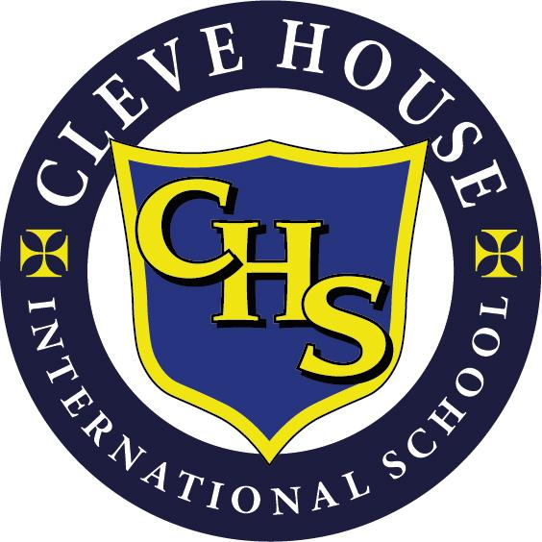
CLEVE HOUSE INTERNATIONAL SCHOOL
AND PRESCHOOL
DISABILITY POLICY

The school has a legal duty to be non-discriminatory towards disabled students and staff and to provide equal access and opportunities to the curriculum.

- AIMS

- Support the ethos of the school as a non-denominational community which respects the rights of all pupils to have equal access to the curriculum, extra- curricular activities and other services within reason.
- Equally value and encourage all children and staff.
- Foster positive attitudes towards disability in our community
- Notwithstanding the above and the school’s desire to enrich the lives of all our pupils and staff by pursuing an inclusive policy for all pupils and staff which reflects the diversity of the outside world, the school places equal importance for ensuring that no pupil’s education and progress is impaired by the behaviour of another pupil.

To achieve our aims the school has produced this Disability Policy.

We will:

- Review the school’s Disability Policy and Accessibility plan regularly.
- Make recommendations with a view to improving the accessibility of its education to pupils and prospective pupils with disabilities by means of reasonable adjustments.

2 ADMISSION TO THE SCHOOL

- Depends upon prospective pupils meeting the school’s entry criteria.
- The school must feel reasonably sure that throughout the pupil’s time at Cleve House International School it will be able to educate the prospective pupil to the best of his /her potential and in line with the general standards achieved by the pupils.
- The school’s policy is to apply these criteria to all potential pupils regardless of any disability. The school has a legal obligation to make reasonable adjustments not to put any disabled pupils or potential pupils at a substantial disadvantage compared with other pupils who are not disadvantaged because of disability.
- Cleve House International requires parents to inform the school in respect of any disability a prospective pupil may have upon application to the school for a prospectus.
- In assessing any pupil or prospective pupil the school may take such advice and require such assessments from possibly an educational psychologist and to follow recommendations as it regards appropriate.
- With prior notification of disability supported by recommendation of an educational psychologist’s report the school will consider carefully and fully the suitability of Cleve House International School and Preschoolfor the prospective pupil.

3 PHYSICAL ACCESS

The school is not purpose built and some of the original 19th century design features may present certain access constraints.

The possibility of change may be limited.

- The school regularly reviews access and seeks to develop and refurbish the buildings in accordance with disabled access requirements whenever possible.
- Due to the age and design of the building it is necessary for some pupils to access their teaching rooms and some of the school’s facilities by using stairs or steps.

4 EDUCATION

- Staff will continue to be made aware of pupils with Disability or Special Educational Needs by the Head Teacher or the SENCO.
- Staff will continue to be made aware of strategies to make ’reasonable adjustments’ within the classroom so as to ensure disabled students are not at a substantial disadvantage in accessing the curriculum.
- Staff will need to adapt their teaching to the learning patterns of all the pupils according to their abilities and the necessary differentiation should be reflected in their lesson plans.
- The implementation of reasonable adjustments to classroom management, teaching and expectations should not hinder the progress of other pupils, nor their Health and Safety (eg workshops and sports equipment).
- The school as an independent school is not required under legislation to provide auxiliary support such as classroom assistants or auxiliary aids eg laptops or hearing loops but will endeavour to do so when possible.

5 SPORTING AND RECREATIONAL ACTIVITIES

- The school will continue to provide equal access to all school activities for disabled pupils within the constraints and physical nature of the site, the budgetary costs, the Health and Safety implications and the difficulties of supervision.
- Individual Risk Assessments and management strategies will be provided for the disabled pupils engaged in school activities.

6 WELFARE AWARENESS

- Staff and pupils are to be made aware of disability and understand its effects and accept and support disabled pupils as part of school life. (eg PSHE and Assemblies.)
- Appropriate staff training will take place to enhance the understanding of disability and the need to provide reasonable adjustments in compliance with our legal duties to improve our educational provision.
- The School’s Equal Opportunities Policy, Bullying Policy, Codes of Behaviour and staff guidance advice will reflect inclusiveness and the difficulties faced by disabled pupils, and will thereby improve understanding and integration.
- The School will agree with parents the appropriate regular means of communication with regard to the pupils progress reports and behavioural issues and the effects of any medication.

7 RELATED POLICIES

PSHE
SEN
Behaviour Policy
Anti Bullying Policy
Equal Opportunities Policy
Health and Safety Policy
Safeguarding Children and Child Protection Policy

Last revised November 2023
Date for revision November 2024

